**WEEK – 13**

**1#** Write a user defined function swap () in C to exchange the values of two variable with using third variable and also without using third variable. (use the concept of call be value and call by reference).

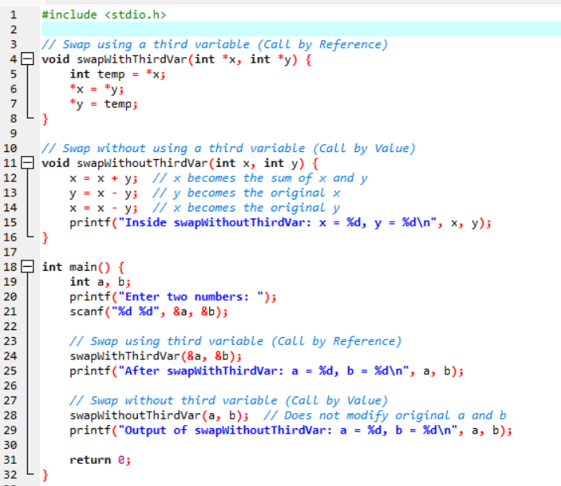

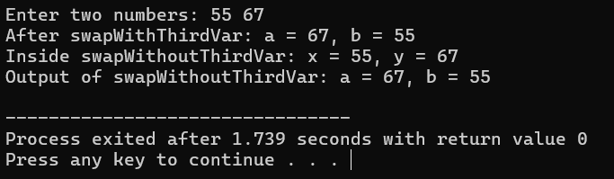

**2#** Write a program to find the factorial of a given number using recursion.

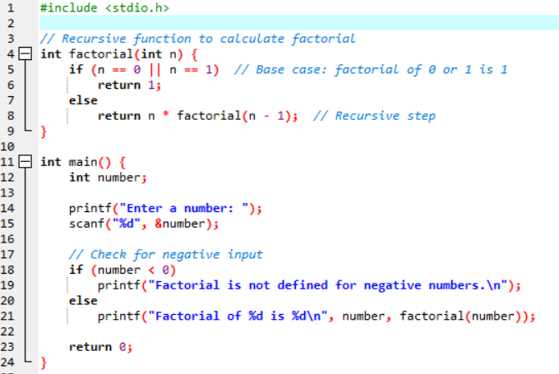

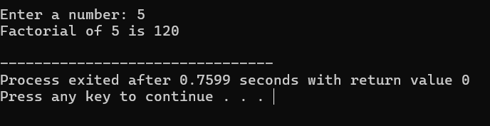

**3#** Write a program in C to print the Fibonacci series up to N terms using recursion.

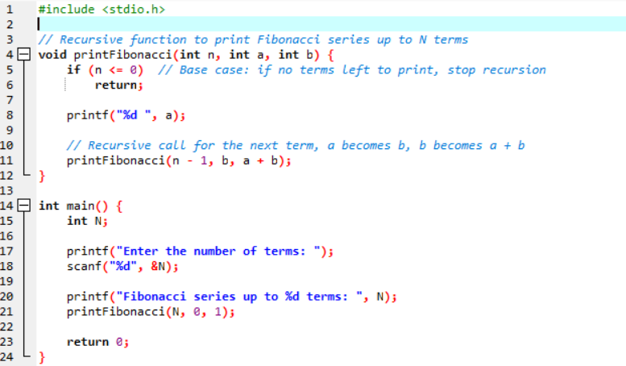

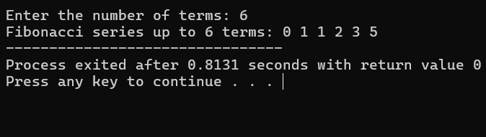

**4#** Write a program in C to store n elements in an array and print the elements using pointer

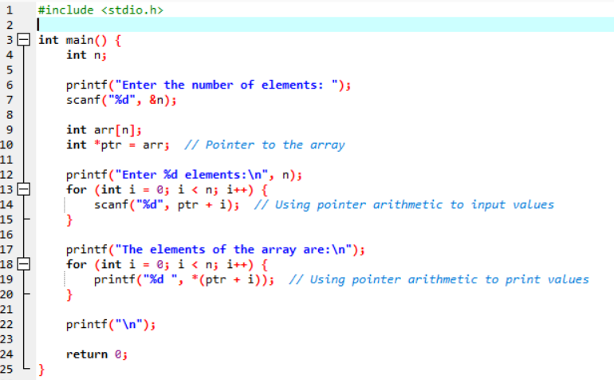

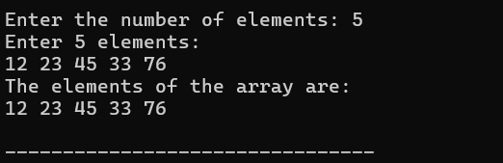

**5#** Write a function countEven (int*, int) which receives an integer array and its size, and returns the number of even numbers in the array.

